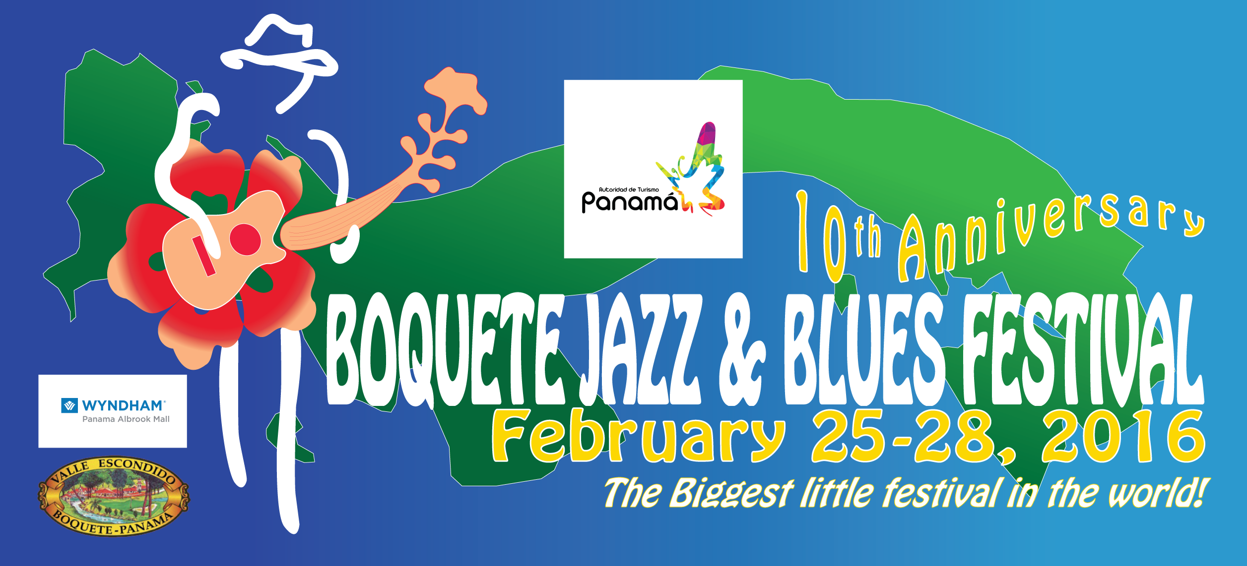
Preview program of the Boquete Jazz & Blues Festival 2016 (Subject to change)

Wednesday, February 24, 2016
7pm - ??? Warm-up jam at Baru restaurant, with the Edgar Vargas trio. $5 at the door. Included in jam package

Thursday, February 25, 2016
Boquete goes New Orleans!
12pm – 1:00pm New Orleans style street parade with Pollera and Congo dance groups in the streets of Boquete. Face painting & set-up starts at the BCP parking lot at 10am
1:00 pm - 4:00 pm Free concert in the park, with Deanna Bogart, Lee Oskar, L.A. Smith and more, and students of local schools as part of our Music for Schools program
4:00 pm - 6:00 pm Open mic at Baru restaurant, donation $5, at the door, included in jam package
8:00 pm - 12:30am Jam at Mike's Global Grill, hosted by John Carney and Rigoberto Coba, donation $15, at the door. Included in jam package.

Friday, Feb 26, 2016
1:30 pm - 5 pm Garden party at the Panamonte hotel. A taste of everything, hosted by Deanna Bogart and with the Luca Ciarla quartet from Italy, donation $15 at the door. Included in jam package.
6:00pm - 7:30pm Shakura S'Aida unplugged at the BCP theater, admission $20.
8:30pm - 12:30am Jam at the Sabor restaurant, Tommy Castro, Ronnie Baker Brooks, Deanna Bogart, Luca Ciarla quartet, donation $20, at the door. Included in jam package.
Saturday, February 27, 2016
1:30pm - 7pm Open-air festival at the amphitheatre at Valle Escondido
Doors open at 12:30 pm
1:30pm - 2:30pm John Carney
3:00pm - 4:00pm Scott Ambush
4:30pm - 5:30pm Ronnie Baker Brooks
6:00pm - 7:00pm Curtis Salgado
After hours:
8:30pm - 12:30am Jam at The Rock restaurant, hosted by Lee Oskar, Curtis Salgado, Shakura S'Aida, donation $20, at the door. Included in jam package.

Sunday, February 28, 2016
1:30pm - 7pm Open-air festival at the amphitheatre at Valle Escondido
Doors open at 12:30 pm
1:30pm - 2:30pm Rigoberto Coba Big Band
3:00pm - 4:00pm Marshall Keyes
4:30pm - 5:30pm Tommy Castro
6:00pm - 7:00pm Grand finale All-Star band
After hours:
8:30pm - 12:30am Jam at Mike's Global Grill, hosted by Marshall Keys & Scott Ambush & Alex Brown, donation $15, at the door. Included in jam package.

Tickets:
1-day ticket for Feb 27 or 28: $70
2-day pass: $125

VIP tickets:
2-day pass: $185

VIP tickets include special seating with seat cushion, and discounts on food&beverages at the festival bars in the amphitheater, plus a special room rate of $89 at the Albrook Mall Tryp hotel before and after the festival until Dec. 31, 2016
http://www.boquetejazzandbluesfestival.com/the-ticket-page.html

According to Panamanian law a sales tax of 7% will be added to the ticket prices shown above.

Rules for access of children: Restrictions apply. Please check the festival rules on our website.

Jam package: $75 (savings of $20!)
Admission to five after-hours jams, the garden party and one afternoon open-mic session will be granted on a tax-free donation basis.. Donations for individual events will be collected at the door.

Tickets and jam packages are available online via our website at
http://www.boquetejazzandbluesfestival.com/the-ticket-page.html

Online purchases of jam packages are tax-free but are subject to an added service fee of 4.95%

Buy your tickets locally at the Tuesday market in Boquete and at Mailboxes ETC. in Coronado,

The exlusive 2016 Fedora Club
The 2016 BJBF Fedora Club is limited to 50 members. Membership is by invitation only
Check out details on the Fedora Club page of our website.
www.boquetejazzandbluesfestival.com

